Nicolas P. Java code

package Sorting;

import java.util.Random;
import java.util.*;
import javax.swing.JOptionPane;

public class AssessmentAll {
static boolean flag=false;
static String temp;
static int inttemp;
static String SearchValue;
static int SearchValueint;
static boolean found=false;
static String printer="";
static boolean Found=false;
static int index;
static int tempor;
static String ErrorMessage="";
static int foundfound=0;

public static void main(String[] args) {
String a[]= new String [1];
int b[]=new int[1];

int z=0;
String Decision1=JOptionPane.showInputDialog(null, "You can perform 4 different algorithms. Do you want to use a bubblesort(b)(it also shows you the time complexity if you sort numbers), a selection sort(s), a linear search(l) or a binary search (n)?");
Decision1=Decision1.toLowerCase();
if(Decision1.contains("b")){
bubblesort(a);
}
if(Decision1.contains("s")){
selectionsort(b);
}
if(Decision1.contains("l")) {
linearSearch(a);
}
if(Decision1.contains("n")) {
Binary(a);
}

}
public static void bubblesort (String[] a) {
String WordsorNum=JOptionPane.showInputDialog(null, "Do you want to enter numbers(n) or words(w) ?");
WordsorNum=WordsorNum.toLowerCase();
; if(WordsorNum.equals("w")){
String Decision=JOptionPane.showInputDialog(null, "Do you want to enter your own array(o) or use a sample array(s)");
Decision=Decision.toLowerCase();
//The user can choose here between entering his own words which will create an array and between using a pre made array
// with the values "q","w","e","r","t","y","u","i","o","p","a","f"
if(Decision.equals("o")) {
int len=Integer.parseInt(JOptionPane.showInputDialog(null, "How many words do you want to sort "));
//Length of array has to be defined before initializing array so program asks user for this information
String array[]= new String [len];
//different methods are now executed all with the argument array which is therefore passed on from one method to the next
assignmentString(array);
bubblesortsort(array);
printstatementString(array);
}
if(Decision.equals("s")){
String array[]= {"q","w","e","r","t","y","u","i","o","p","a","f"};
//Here is the pre-made array. It doesn't require any user input so program just directly sorts this.
bubblesortsort(array);
printstatementString(array);
}
}
if(WordsorNum.equals("n")) {
String Decision=JOptionPane.showInputDialog(null, "Do you want to enter your own array(o) or use a sample array. This sample array will first sort an array "+"\n containing 1000 randomly generated integers, then 10000 and then 50000 compairing their time complexity.(s)");
Decision=Decision.toLowerCase();
//The user can choose here between entering his own words which will create an array and between using a pre made array
// with the values "q","w","e","r","t","y","u","i","o","p","a","f"
if(Decision.equals("o")) {
int len=Integer.parseInt(JOptionPane.showInputDialog(null, "How many numbers do you want to sort "));
//Length of array has to be defined before initializing array so program asks user for this information
int array[]= new int [len];
//different methods are now executed all with the argument array which is therefore passed on from one method to the next
assignmentint(array);
bubblesortsortint(array);
printstatementint(array);
}
if(Decision.equals("s")){
Random random = new Random();
int[] array = random.ints(100, 1,100001).toArray();
//Here is the pre-made array. It doesn't require any user input so program just directly sorts this.
long timefor100;
long timefor1000;
long timefor10000;
long start = System.currentTimeMillis();
bubblesortsortint(array);
long end = System.currentTimeMillis();;
timefor100=(end - start);
printstatementinthorizontal(array);
System.out.println(" ");
System.out.println("For an array of 100 it took : "+timefor100+" ms.");
end=0;
start=0;

array = random.ints(1000, 1,100001).toArray();
//Here is the pre-made array. It doesn't require any user input so program just directly sorts this.
start = System.currentTimeMillis();
bubblesortsortint(array);
end = System.currentTimeMillis();;
timefor1000=(end - start);
printstatementinthorizontal(array);
System.out.println(" ");
System.out.println("For an array of 1000 it took : "+timefor1000+" ms.");
end=0;
start=0;

array = random.ints(10000, 1,100001).toArray();
//Here is the pre-made array. It doesn't require any user input so program just directly sorts this.
start = System.currentTimeMillis();
bubblesortsortint(array);
end = System.currentTimeMillis();;
timefor10000=(end - start);
printstatementinthorizontal(array);
System.out.println(" ");
System.out.println("For an array of 10000 it took : "+timefor10000+" ms.");
}

}

}
public static void selectionsort(int[] a) {
String Decision=JOptionPane.showInputDialog(null, "Do you want to enter your own array(o) or use a sample array(s) or 1000 random numbers between 1 and 100000(r)");
Decision=Decision.toLowerCase();
if(Decision.equals("o")) {
//own array chosen
int len=Integer.parseInt(JOptionPane.showInputDialog(null, "How many numbers do you want to sort "));
int array[]= new int [len];
assignmentint(array);
//own array created
selectionsortsort(array);
//selection sort run
printstatementint(array);
//array print method run
}
if(Decision.equals("s")){
int array[]= {9999,997,65,43,1,23,12,35,64,33,37,88,999,22,212};
//sample array 9999,997,65,43,1,23,12,35,64,33,37,88,999,22,212
selectionsortsort(array);
//selection sort run
printstatementint(array);
//array printed
}
if(Decision.equals("r")) {
Random random = new Random();
int[] array = random.ints(1000, 1,100000).toArray();
//each index of array of length 1000 random number between 1 and 100000 assigned to show time complexity
selectionsortsort(array);
//selection sort run
printstatementint(array);
//array printed
}

}
public static void bubblesortsort(String[] array) {
while(flag==false) {
//flag acts as signal whether or not two values in the array swapped places. If they didn't the array is sorted
flag=true;
//flag is set to true so program breaks if not set back to false inside of the if statement.
for(int a=1; a<array.length; a++) {
if(array[a].toLowerCase().compareTo(array[a-1].toLowerCase())<0) {
//if the first value is alphabetically behind the second value this line will return a negative number.
//This can be used because whenever this occurs the two values have to be swapped
temp=array[a];
array[a]=array[a-1];
array[a-1]=temp;
//temporary storage needed because both values have to be overwritten so that one of the values doesn't go lost
flag=false;
//flag set to false to signal that two values were sorted
}

}
}
flag=false;
}
public static void bubblesortsortint(int[] array) {
while(flag==false) {
//flag acts as signal whether or not two values in the array swapped places. If they didn't the array is sorted
flag=true;
//flag is set to true so program breaks if not set back to false inside of the if statement.
for(int a=1; a<array.length; a++) {
if(array[a]<array[a-1]) {
//if the first value is alphabetically behind the second value this line will return a negative number.
//This can be used because whenever this occurs the two values have to be swapped
tempor=array[a];
array[a]=array[a-1];
array[a-1]=tempor;
//temporary storage needed because both values have to be overwritten so that one of the values doesn't go lost
flag=false;
//flag set to false to signal that two values were sorted
}
}
}
flag=false;
}
public static void selectionsortsort(int[] array) {
int min=0;
//minimum variable initialized
for(int b=0; b<array.length-1; b++) {
//one by one moves through unsorted part of array
min=b;
for(int c=b+1;c<array.length;c++) {
if(array[c]<array[min]) {
min=c;
//minimum value from unsorted part found
}
}
if(min!=b) {
inttemp=array[min];
array[min]=array[b];
array[b]=inttemp;
//minimum value assigned to sorted part of array. Swapped with first element
}
}

}

public static void printstatementString(String[] array) {
for(int b=0; b<array.length; b++) {
System.out.println(b+1+". "+array[b]);
//Simple statement to print the values of the array
}
}
public static void printstatementint(int[] array) {
for(int b=0; b<array.length; b++) {
System.out.println(b+1+". "+array[b]);
//Simple statement to print the values of the array. Had to be changed to integers to be applicable for the selection sort
}
}
public static void printstatementinthorizontal(int[] array) {
for(int b=0; b<array.length; b++) {
System.out.print(+array[b]+", ");
//Simple statement to print the values of the array. Had to be changed to integers to be applicable for the selection sort
}
}
public static void assignmentString(String[] array) {
for(int i=1;i<=array.length;i++) {
array[i-1] = JOptionPane.showInputDialog(null, "Input number: "+i);
}
//Simple line of code that asks the user to enter a value which is then assigned to a index of the array. Made for Bubble Sort
}
public static void assignmentint(int[] array) {
for(int i=1;i<=array.length;i++) {
array[i-1] = Integer.parseInt(JOptionPane.showInputDialog(null, "Input number: "+i));
}
//Simple line of code that asks the user to enter a value which is then assigned to a index of the array. Made for Selection Sort
}

///Bubble Sort and SelectionSort end

public static void linearSearch(String[] args) {
String a=" ";
int z=0;
String DecisionNum=JOptionPane.showInputDialog(null, "Do you want to search a words(w) or numbers array(n)");
//User decides if he wants to search for a word or a number
if(DecisionNum.equals("w")) {
linearsearchString(a);
}
if(DecisionNum.equals("n")) {
linearsearchint(z);
}
//simple if statement to implement users answer and based on that perform right method

}
public static void linearsearchString(String a) {
found=false;
found=false;
String Decision=JOptionPane.showInputDialog(null, "Do you want to create your own array that is to be searched(o) or use a sample array, a shopping list(s)");
//user can create own array that is to be searched or use sample array
Decision=Decision.toLowerCase();
//Decision converted to lower case so that program also recognises users descision if he accidentally has capslock on
if(Decision.equals("o")){
//own array
int len=Integer.parseInt(JOptionPane.showInputDialog(null, "How many words do you want to enter?"));
//to initialize array length of it needs to be known. Program asks user for this
String array[]= new String [len];
assignmentString(array);
//method which asks user to input a word for each index of the array and assigns that index to the word
SearchValue=JOptionPane.showInputDialog(null, "Enter the word you want to seach for");
//Word user searches for is inputted
linearsearchsearchString(array, SearchValue);
//Linear search performed
}
if(Decision.equals("s")){
//sample array with values "Apple","Banana","Cucumbers","Apple","Banana","Cucumber","Bread" used
SearchValue=JOptionPane.showInputDialog(null, "Enter the word you want to seach for");
//Word entered that is to be searched for
String array[]= {"Apple","Banana","Cucumbers","Apple","Banana","Cucumber","Bread"};
linearsearchsearchString(array, SearchValue);
//linear search method performed
}
}
public static void linearsearchint(int z) {
found=false;
found=false;
String Decision=JOptionPane.showInputDialog(null, "Do you want to create your own array that is to be searched(o) or use a sample array with 1000 randomly generated numbers between 1 and 100(s)");
Decision=Decision.toLowerCase();
//User can enter his decision in caps or not
if(Decision.equals("o")){
//own array used
int len=Integer.parseInt(JOptionPane.showInputDialog(null, "How many numbers do you want to enter?"));
//length of array needed to initialize it
int array[]= new int [len];
//array initialized
assignmentint(array);
//assignment method run
SearchValueint=Integer.parseInt(JOptionPane.showInputDialog(null, "Enter the number you want to seach for"));
//Search value is entered
linearsearchsearchint(array, SearchValueint);
//array and search value passed on as arguments into linear search
}
if(Decision.equals("s")){
//sample array used
SearchValueint=Integer.parseInt(JOptionPane.showInputDialog(null, "Enter the number you want to seach for"));
//Search Value entered
Random random = new Random();
int[] array = random.ints(1000, 1,101).toArray();
//Array made with length of 1000 and random numbers between 1 and 100
linearsearchsearchint(array, SearchValueint);
//linear search method run
}
}

public static void linearsearchsearchString(String[] array, String value) {
System.out.print(value+" has been found at location: ");
for(int b=0;b<array.length;b++) {
//for loop which runs through each value of the array and checks if it is equal to the search value
if(array[b].equals(value)) {
System.out.print((b+1)+", ");
//location printed out. Not index
found=true;
}
}
if(found==false) {
//if its not existing in the array
System.out.println("nowhere. The word "+value+" does not exist in this array");
}
}
public static void linearsearchsearchint(int[] array, int value) {
//linear search for integers
System.out.print(value+" has been found at location: ");
for(int b=0;b<array.length;b++) {
//again loops through each index of the array and compares it to the number
if(array[b]==value){
System.out.print((b+1)+", ");
found=true;
}
}
if(found==false) {
//if not found this message lets the user know that the search value doesnt exist in the array
System.out.println("nowhere. The number "+value+" does not exist in this array");
}
}

///Binary Search

public static void Binary(String[] args) {
// TODO Auto-generated method stuff;
String Decision=JOptionPane.showInputDialog(null, "Do you want to perform a binary search on your own array(o) It has to be sorted though, or on a sample array which is already sorted(s)");
//user can perform a binary search on an array of his choosing or a sample array
Decision=Decision.toLowerCase();
//margin for error. Decision still recognized if written in caps
if(Decision.equals("s")) {
//user picked sample array
int SearchValue=Integer.parseInt(JOptionPane.showInputDialog(null, "Enter the number you want to search for"));
//user enters number he wants to search for
int array[]= {1,2,3,4,5,6,7,8,9,10,11,12};
//pre-made array using values 1,2,3,4,5,6,7,8,9,10,11,12
binarysearch(array, 0, array.length, SearchValue);
//binary search method performed in which the arguments are 1. The array itself 2. The minimum value 3. The maximum value 3. The number that is to be searched for
System.out.println("Found at location:"+index+ErrorMessage);
}
//message that can be read in console is outputted
if(Decision.equals("o")) {
//user chooses to make his own array
int len=Integer.parseInt(JOptionPane.showInputDialog(null, "How many numbers do you want to include in your array"));
//self made array requires length to be known in advance
int array[]=new int [len];
//array initialized
assignmentint(array);
//arrays indexes set equal to user input
bubblesortsortint(array);
System.out.println("The sorted array is:");
printstatementinthorizontal(array);
int SearchValue=Integer.parseInt(JOptionPane.showInputDialog(null, "Enter the number you want to search for"));
//number to be searched for is entered
binarysearch(array, 0, array.length-1, SearchValue);
//binary search method performed in which the arguments are 1. The array itself 2. The minimum value 3. The maximum value 3. The number that is to be searched for
System.out.println("Found at location:"+index+ErrorMessage);
//Message read in console outputted
}
}
public static void binarysearch(int[] array, int min,int max,int SearchValue) {
//actual binary search
int mid=-1;
//variable mid initialized
while(Found==false) {
//while loop using a flag that breaks when variable has been found
tempor=mid;
//value of mid temporarily stored in order to check if variable is not in array as only if the first value of mid
//is equal to its changed value if the array is stuck in an infinite loop which happens when
//the value doesn't exist in the array
mid =(min+max-1)/2;
//finds middle of array and narrows down towards the value that is to be searched for
if(mid>=array.length) {
Found=true;
ErrorMessage="The array is not sorted";
//checks if array isn't sorted and if error message would happen
}
if(array[mid]==SearchValue) {
Found=true;
index=mid+1;
//if SearchValue is exactly at the middle
}
if(array[mid]>SearchValue) {
max=mid;
//maximum lowered to narrow down array
}
else{
min=mid;
//minimum increased to narrow down array
}
if(tempor==mid) {
Found=true;
ErrorMessage=" The value is at location "+tempor;
//error check if value is not in array
}
}
}

}
I will only be displaying one path for every algorithm in pictures. The other paths (sorting words etc.) also work.

Bubble Sort
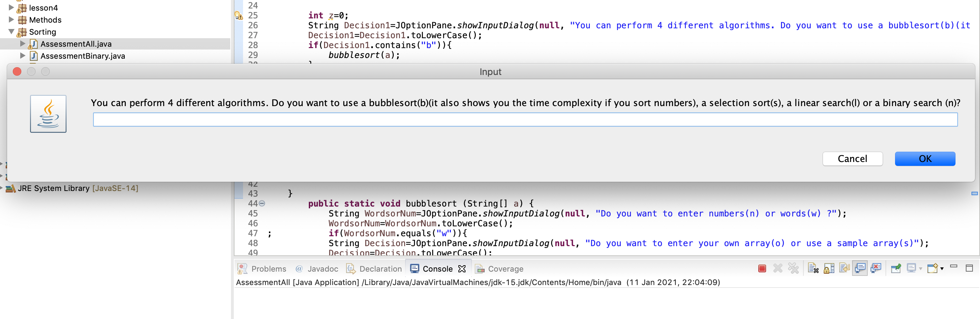

BubbleSort:
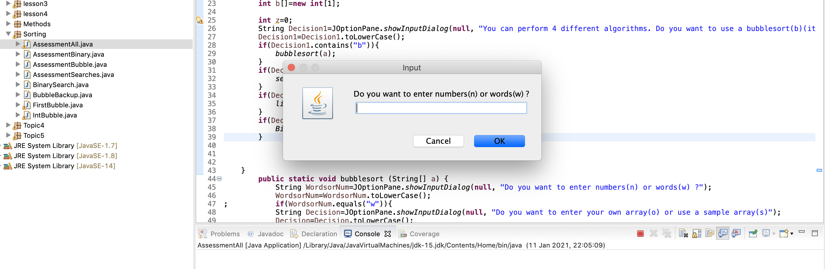
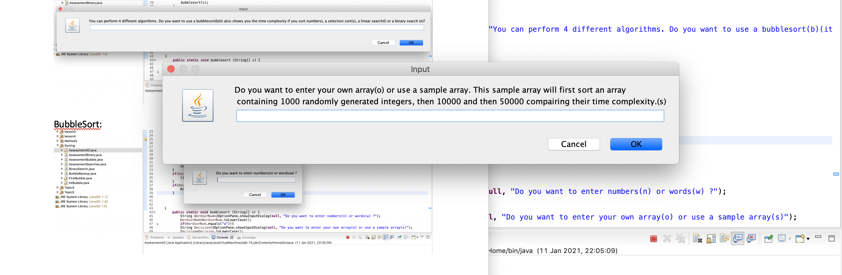

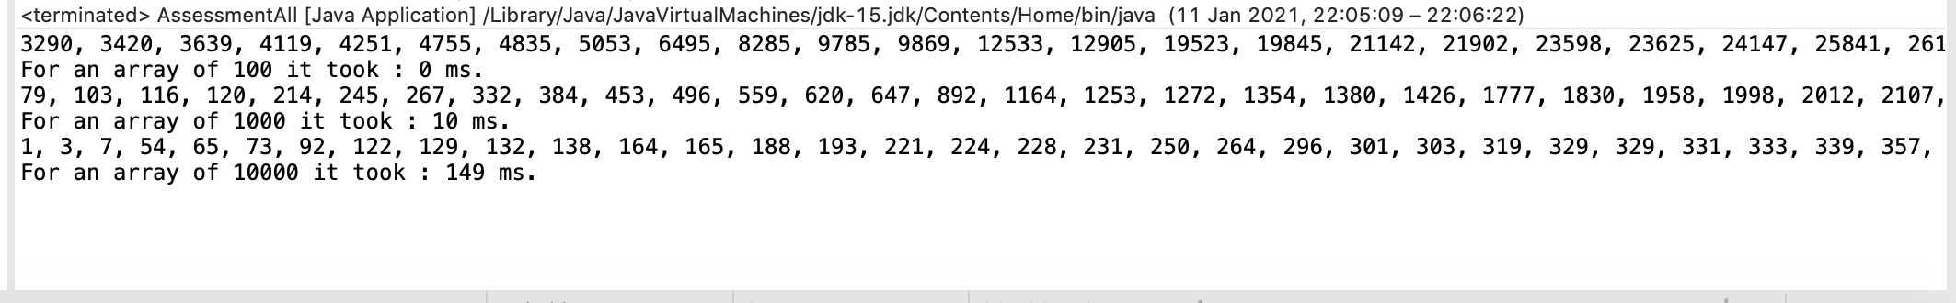

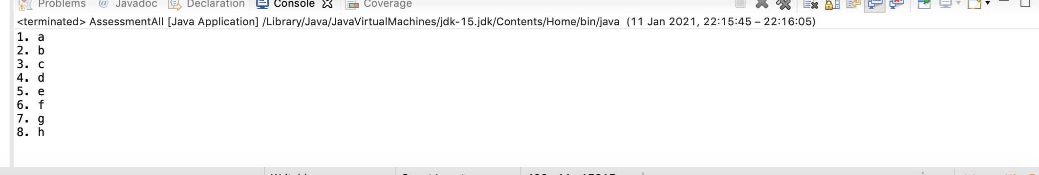
It can also ask the user to enter words which are then sorted using a bubble sort.

Selection Sort:
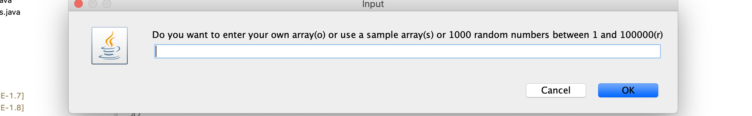

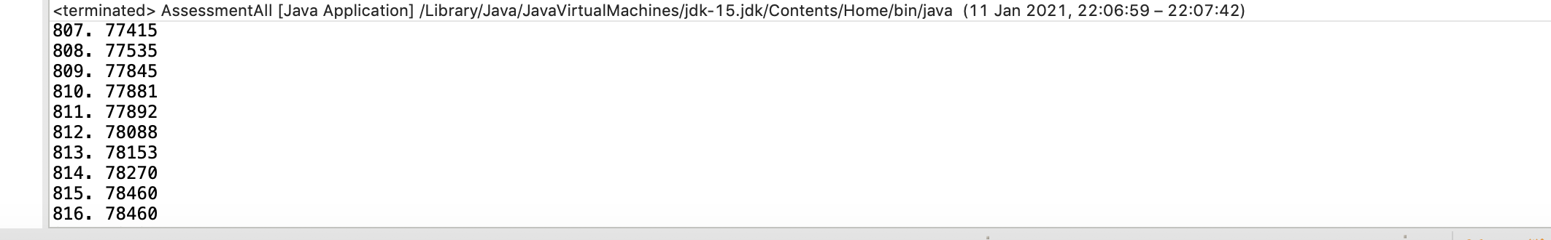

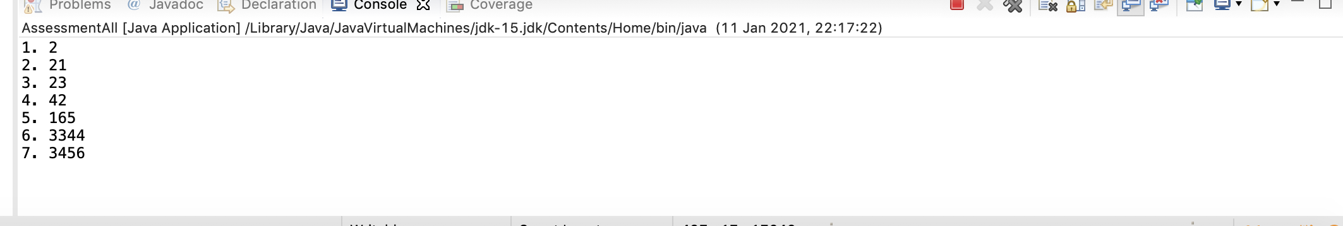
It also lets user enter his own numbers for the array.

Linear Search:
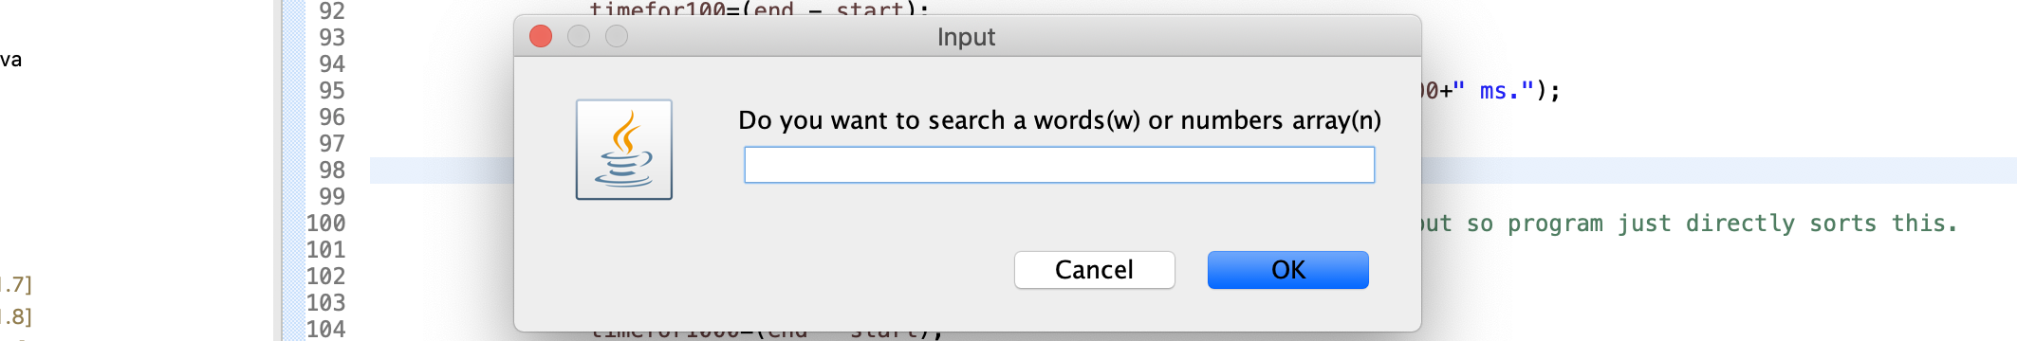

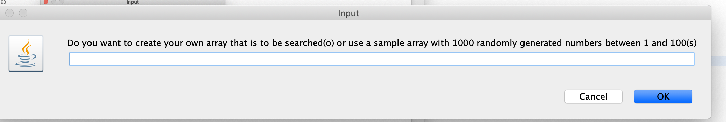

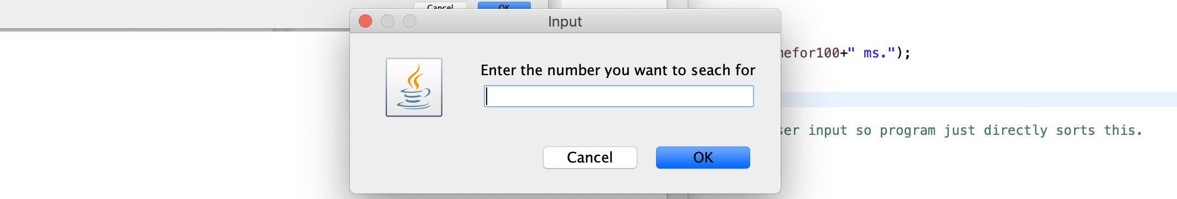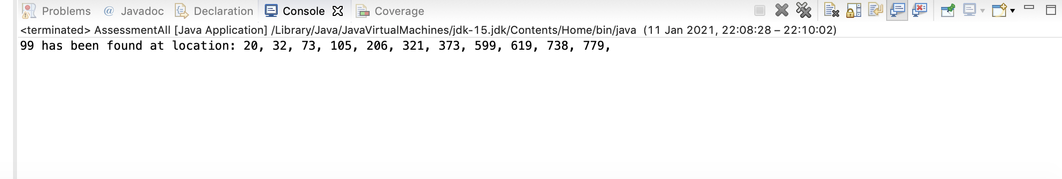

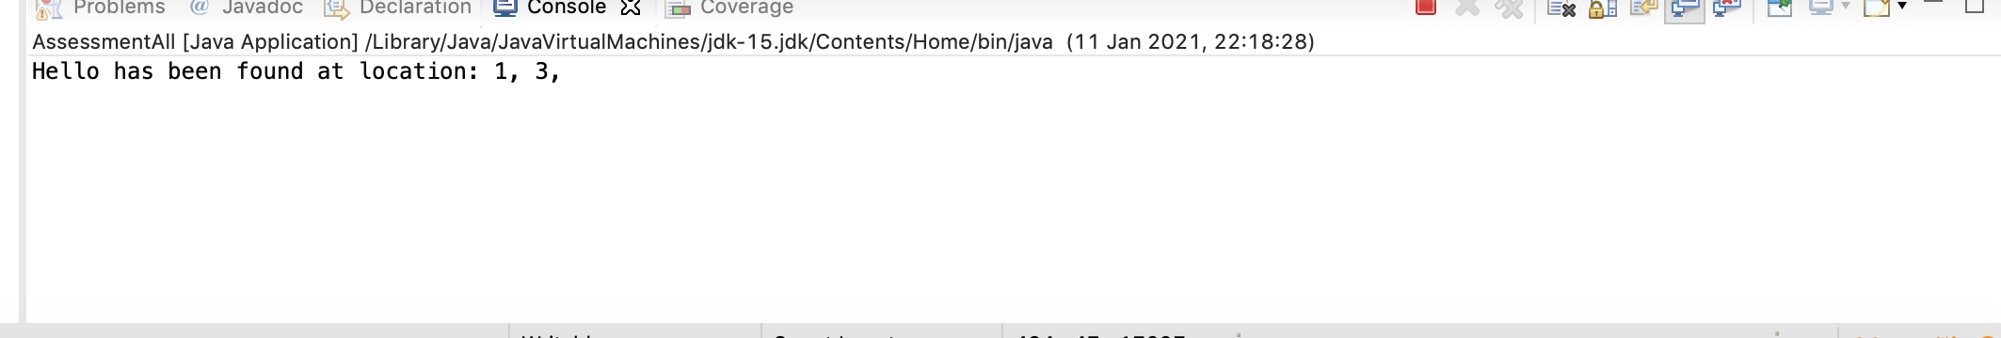

Also lets user create their own array by entering words into JOptionPane and then to search this.
Binary Search

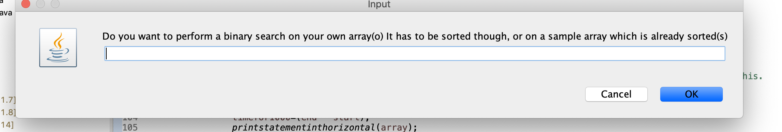

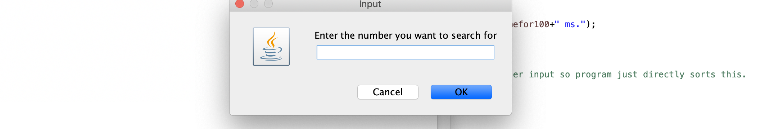

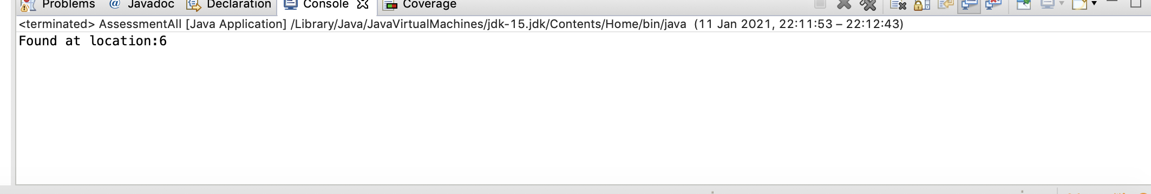

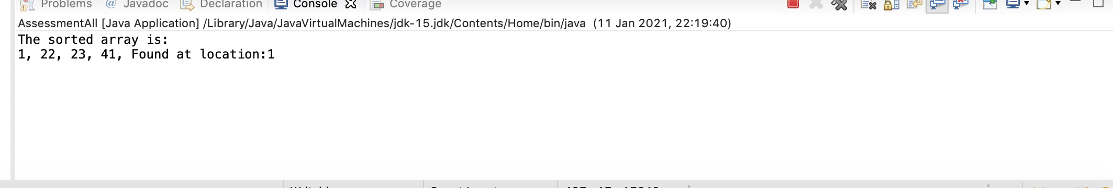

Let’s user enter his own numbers which are then sorted by a bubble sort and then searched for a certain value.

Other Paths in program such as sorting words, creating your own arrays that are to be searched etc. can also be chosen in the program.

